**1. SQL Exercise - Advanced concepts**

**Exercise 1: Ranking and Window Functions**

1. ROW_NUMBER() — Unique Rank Per Category

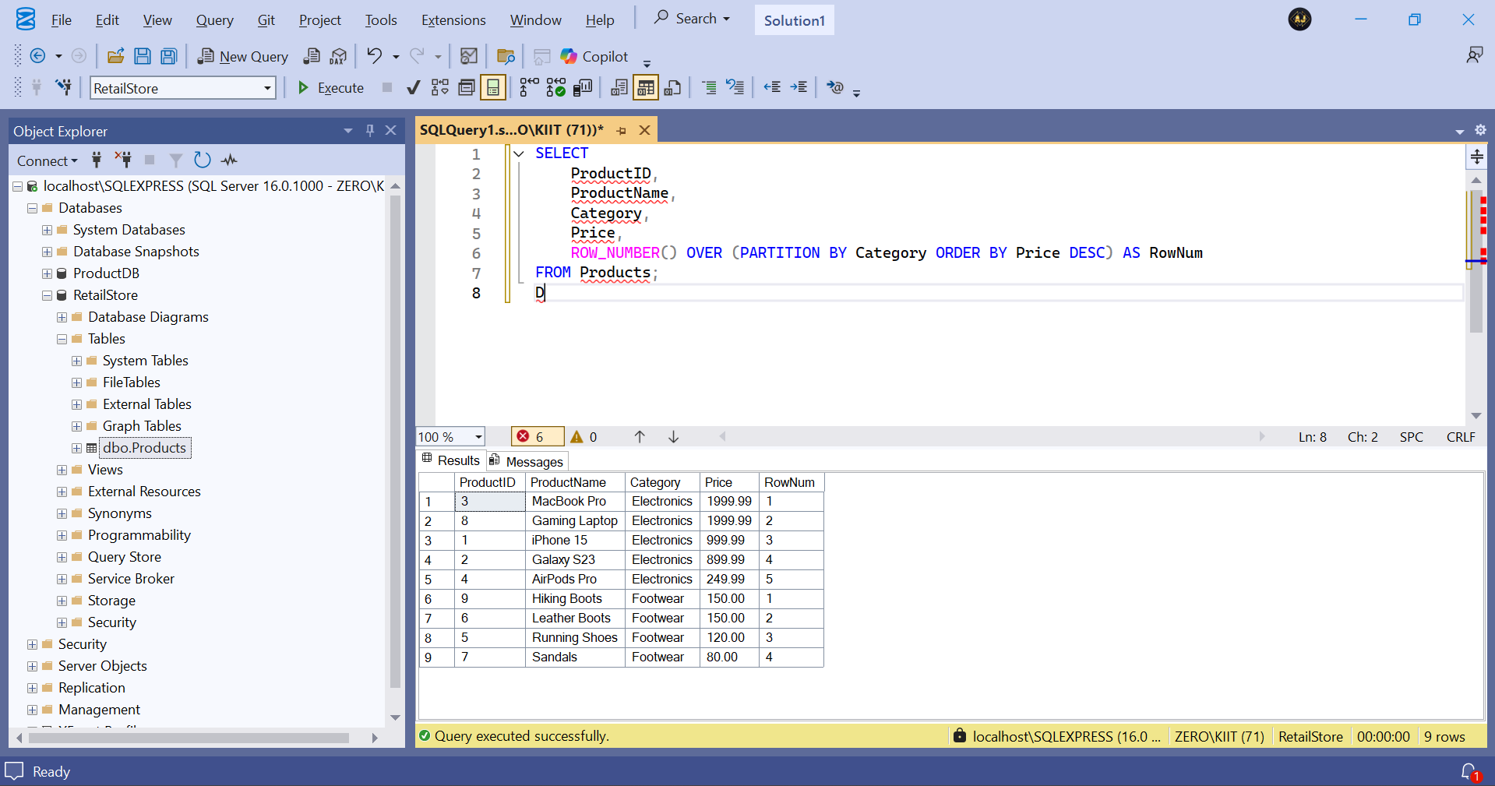

2. RANK() — Allows Ties but Skips Numbers

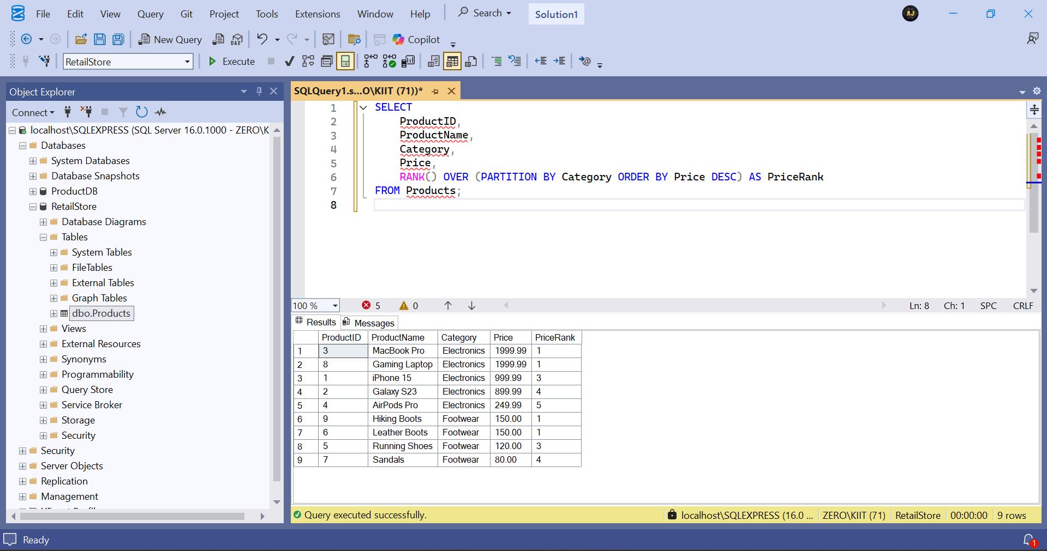

1. DENSE_RANK() — Allows Ties with No Gaps

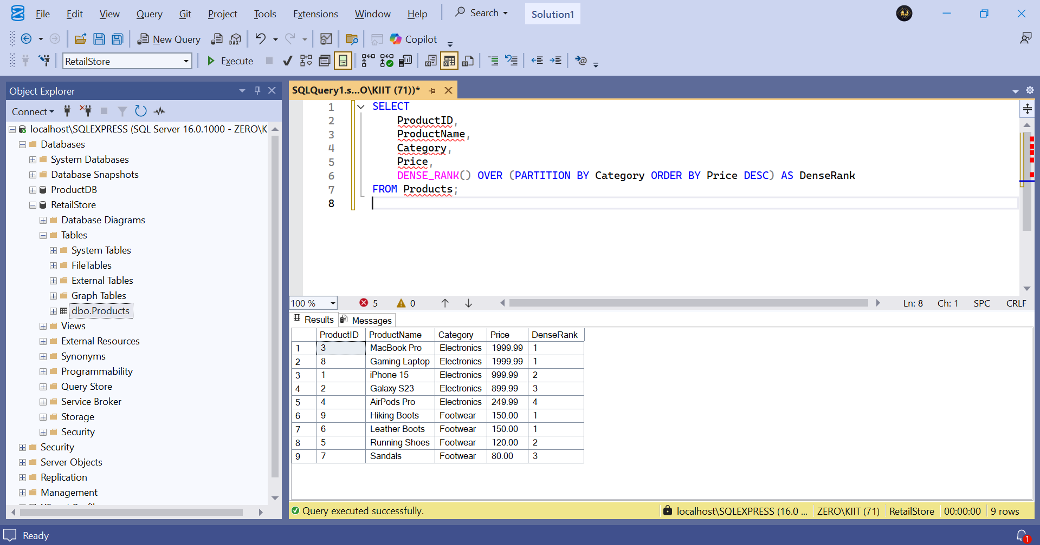

Using ROW_NUMBER() — Strict Top 3

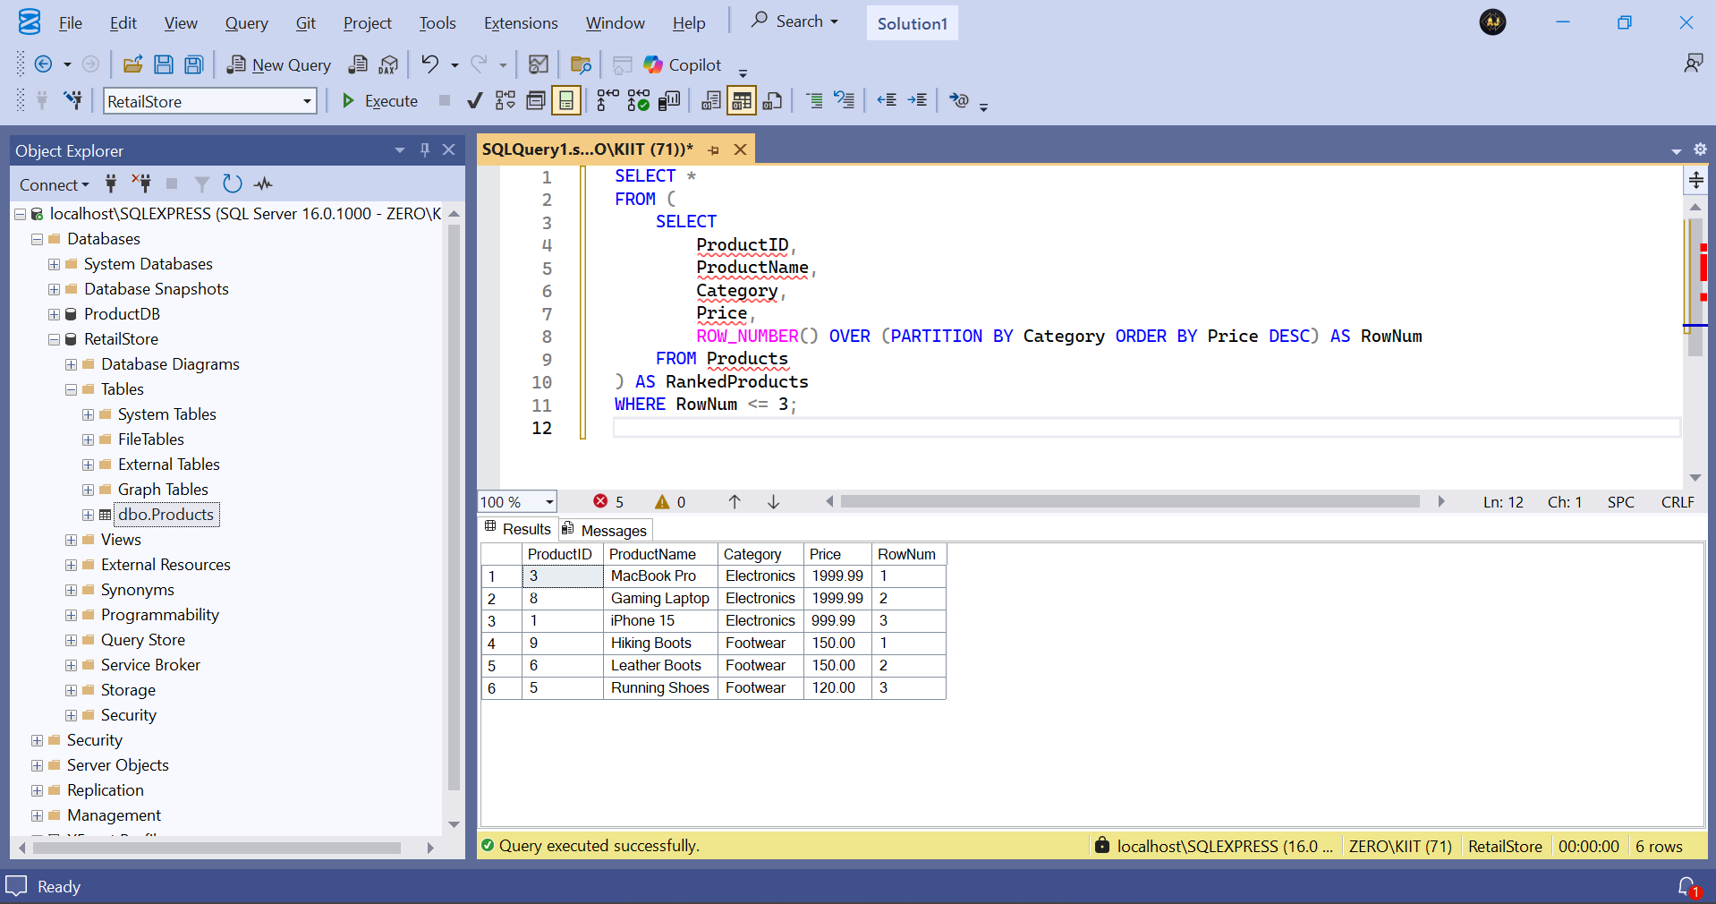

Using RANK() — Includes Tied Prices Even If More Than 3

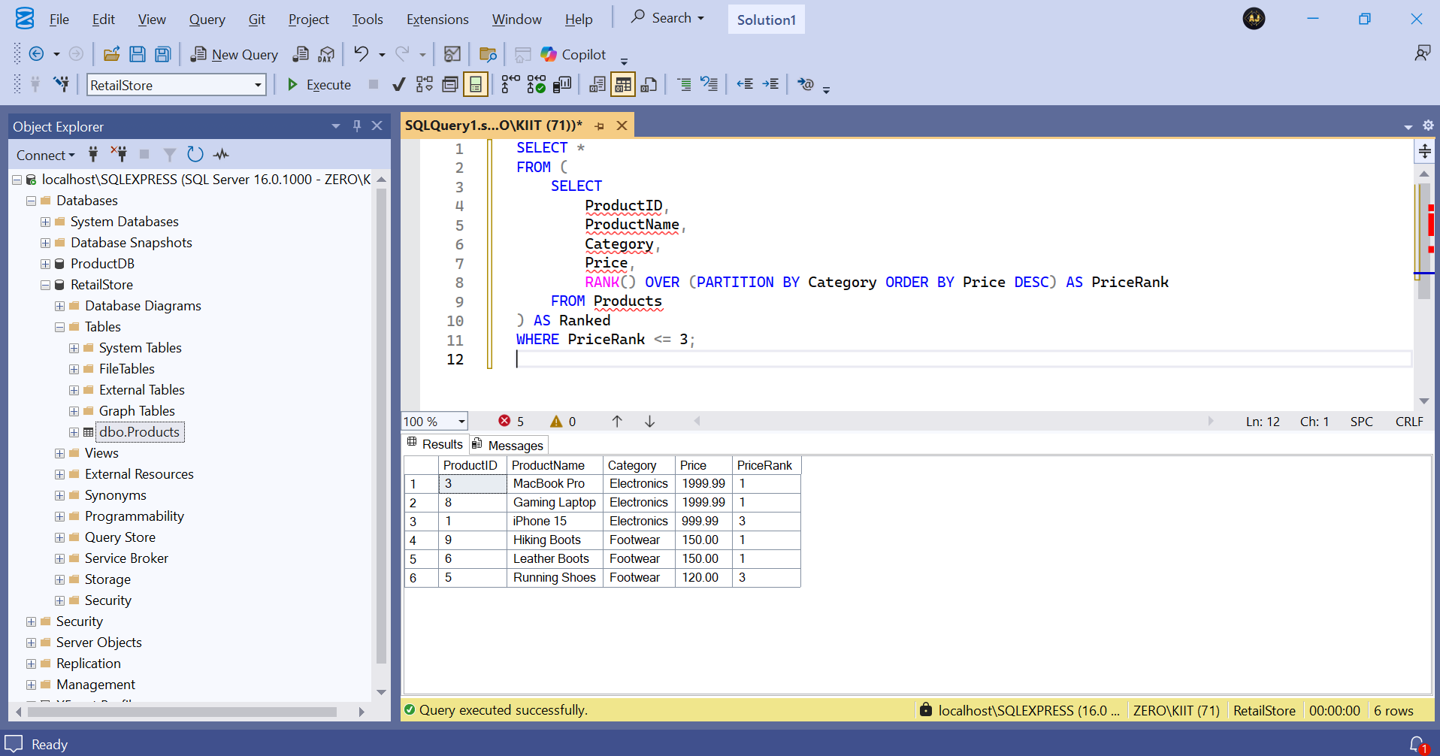

Using DENSE_RANK() — Same as Above But Without Gaps

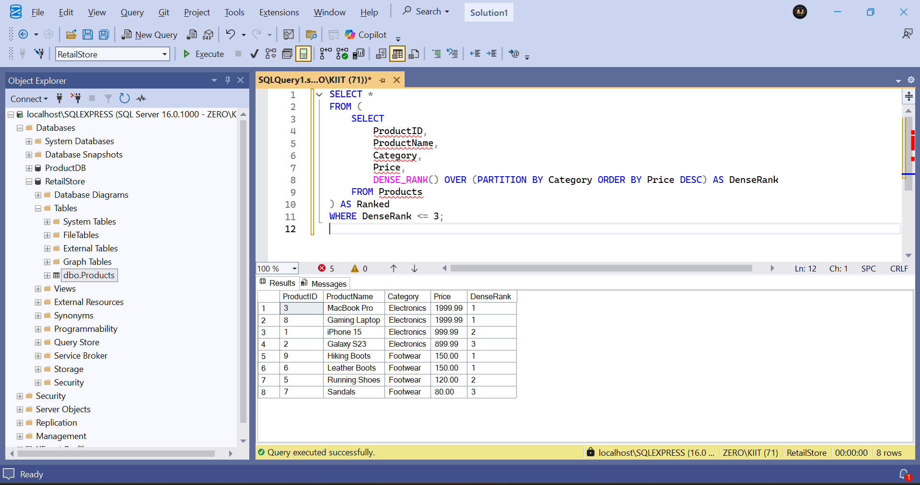

**4. SQL Exercise - Stored procedure**

**Exercise 1: Create a Stored Procedure**

Creation of Employees and Department Tables: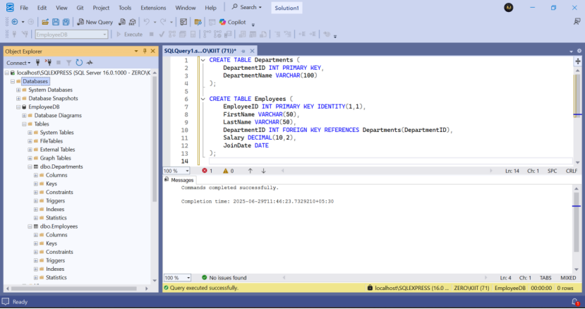

Data Insertion:  
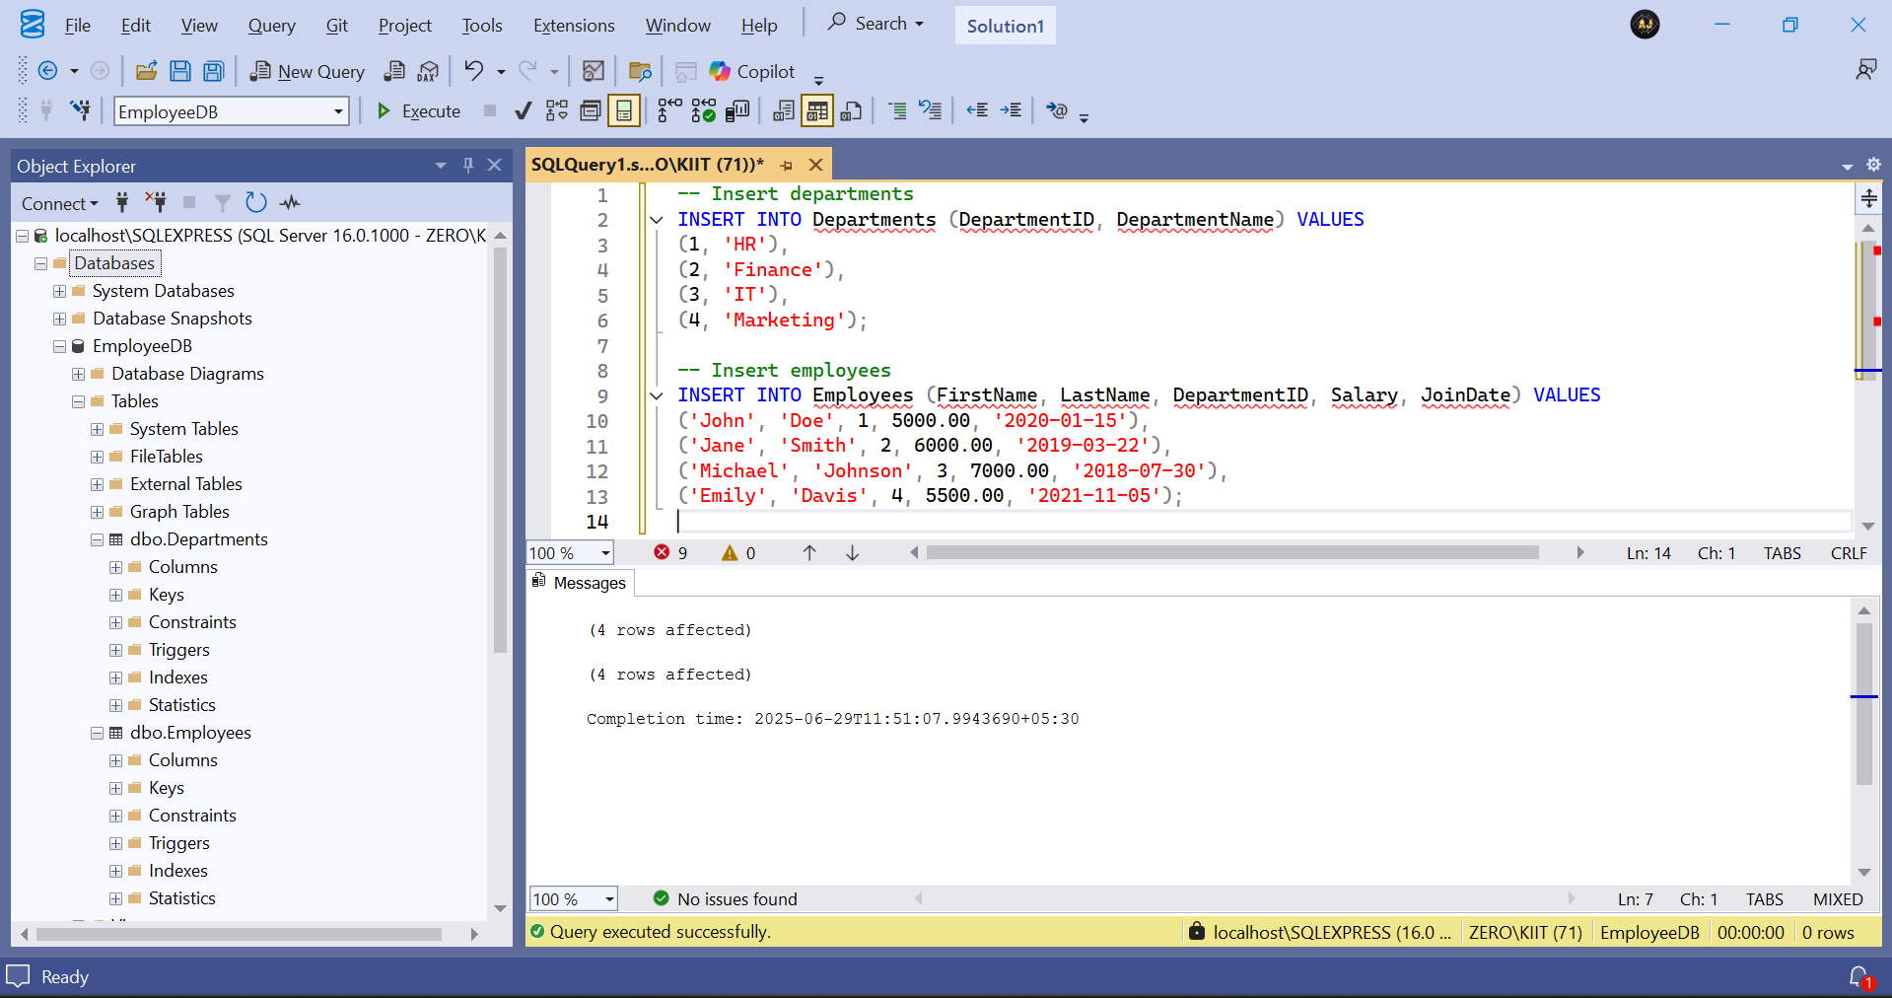

Created Procedure sp_GetEmployeesByDepartment:

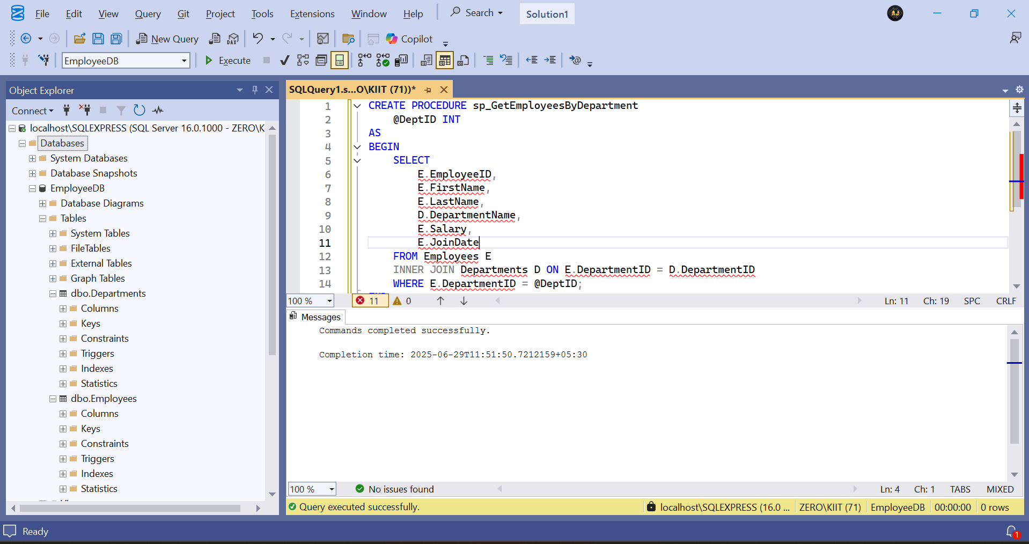

Procedure Execution:

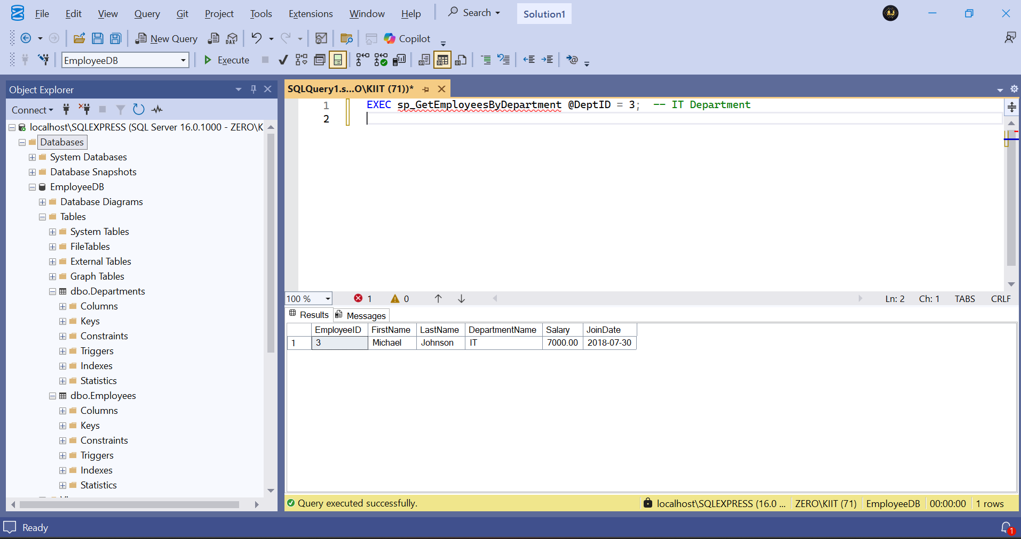

Created the sp_InsertEmployee Procedure:

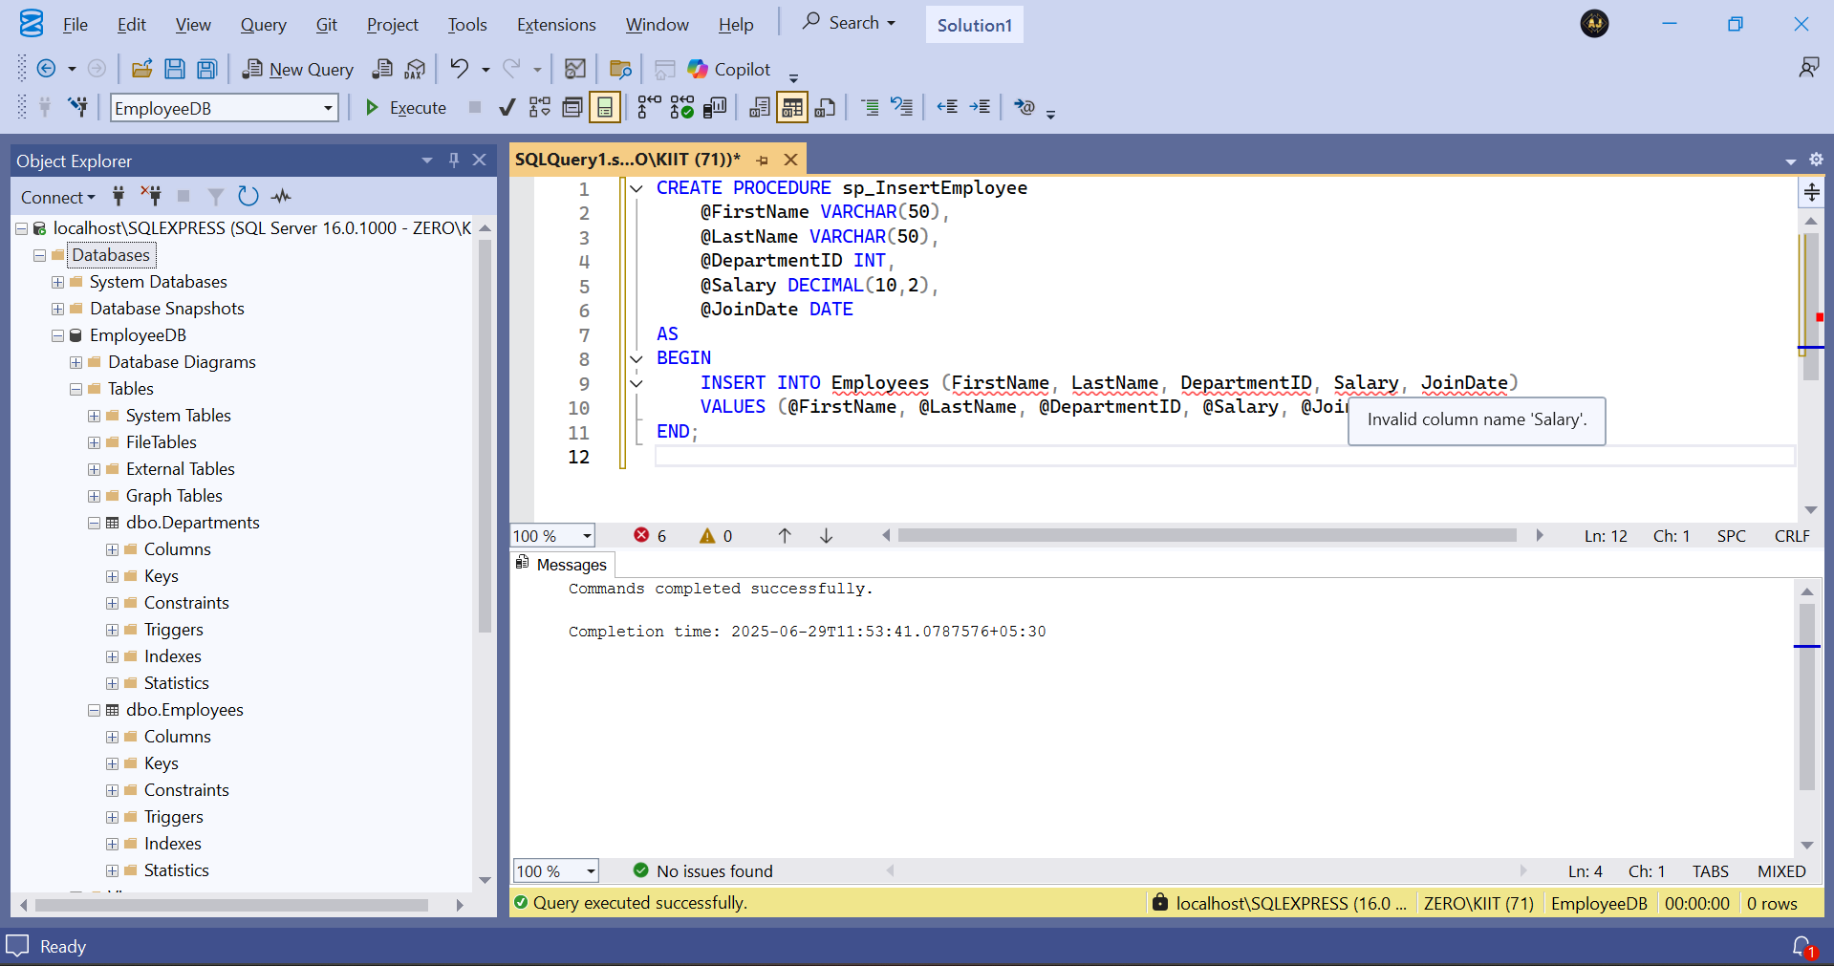

To insert a new employee using procedure:

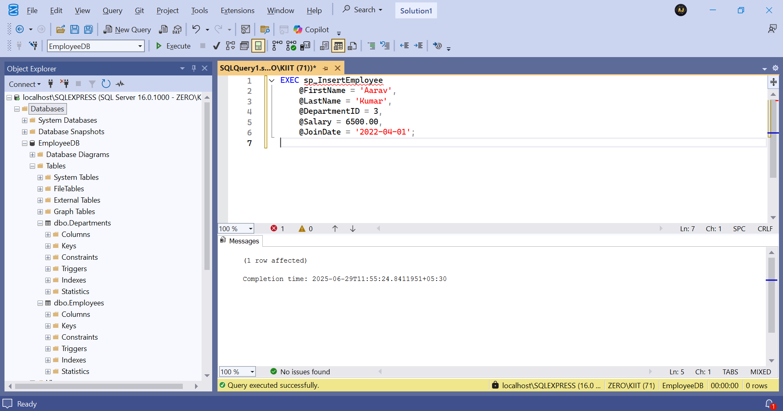

Employees Table:

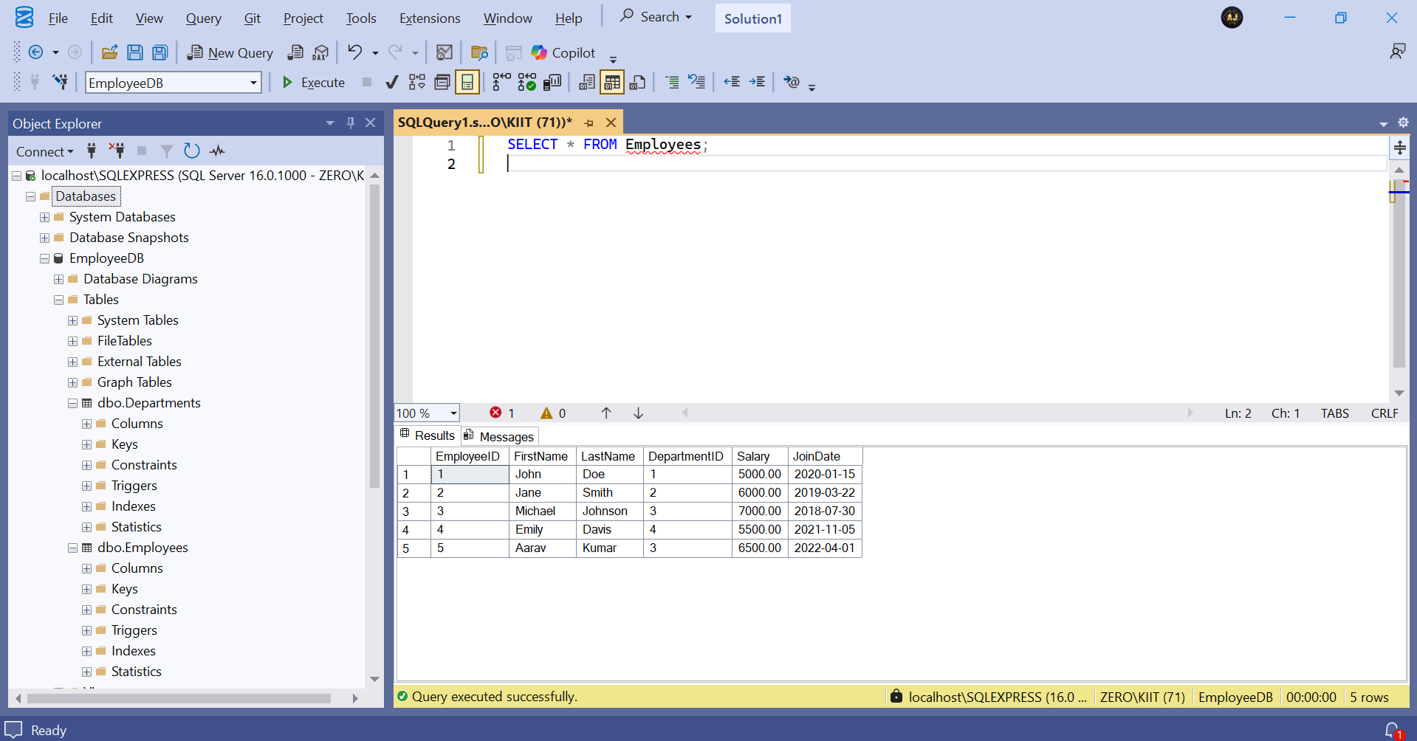

**Exercise 5: Return Data from a Stored Procedure**

Created a new procedure called sp_GetEmployeeCountByDepartment:

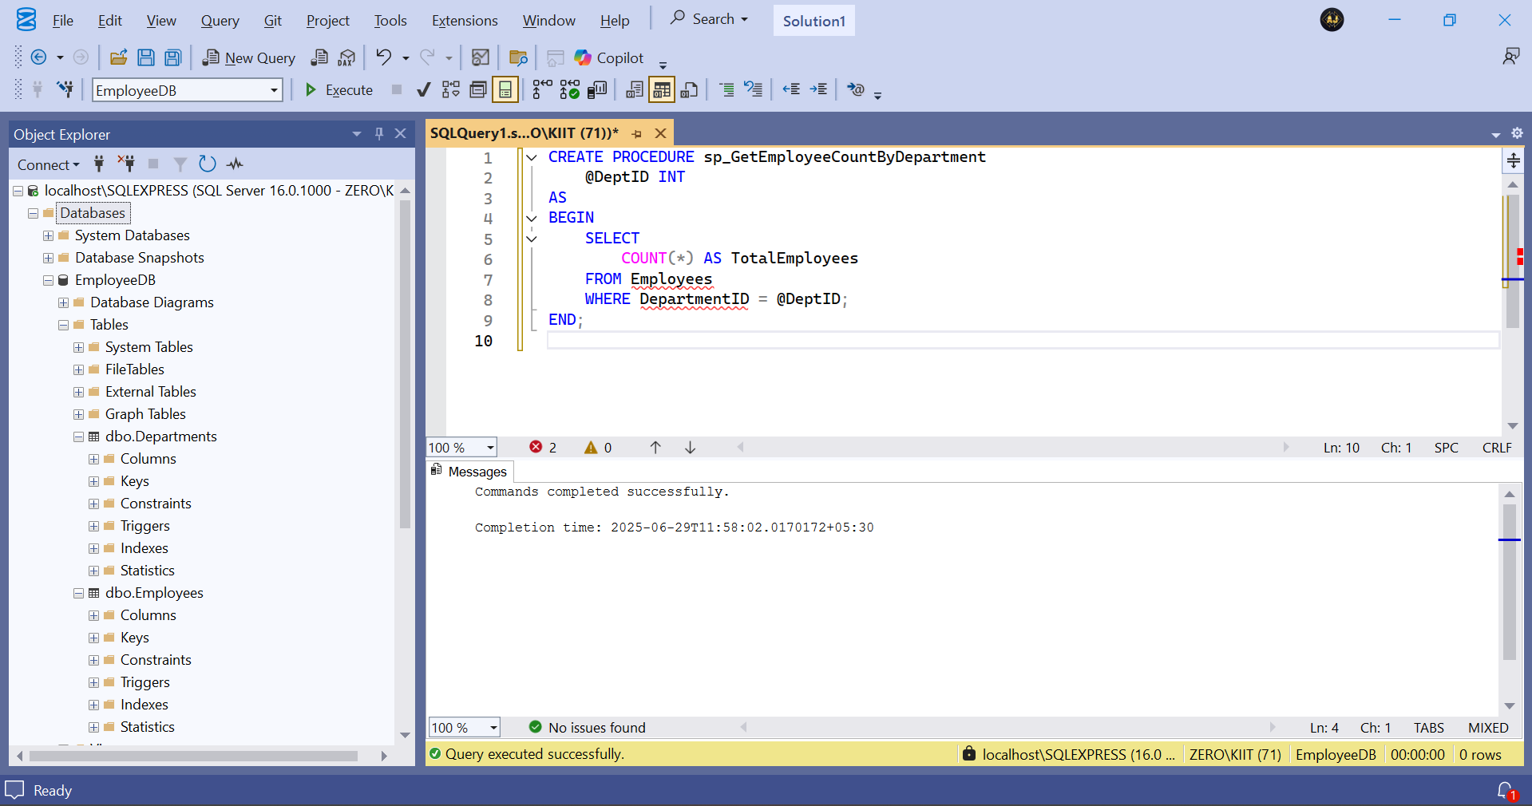

Execution of sp_GetEmployeeCountByDepartment Procedure:

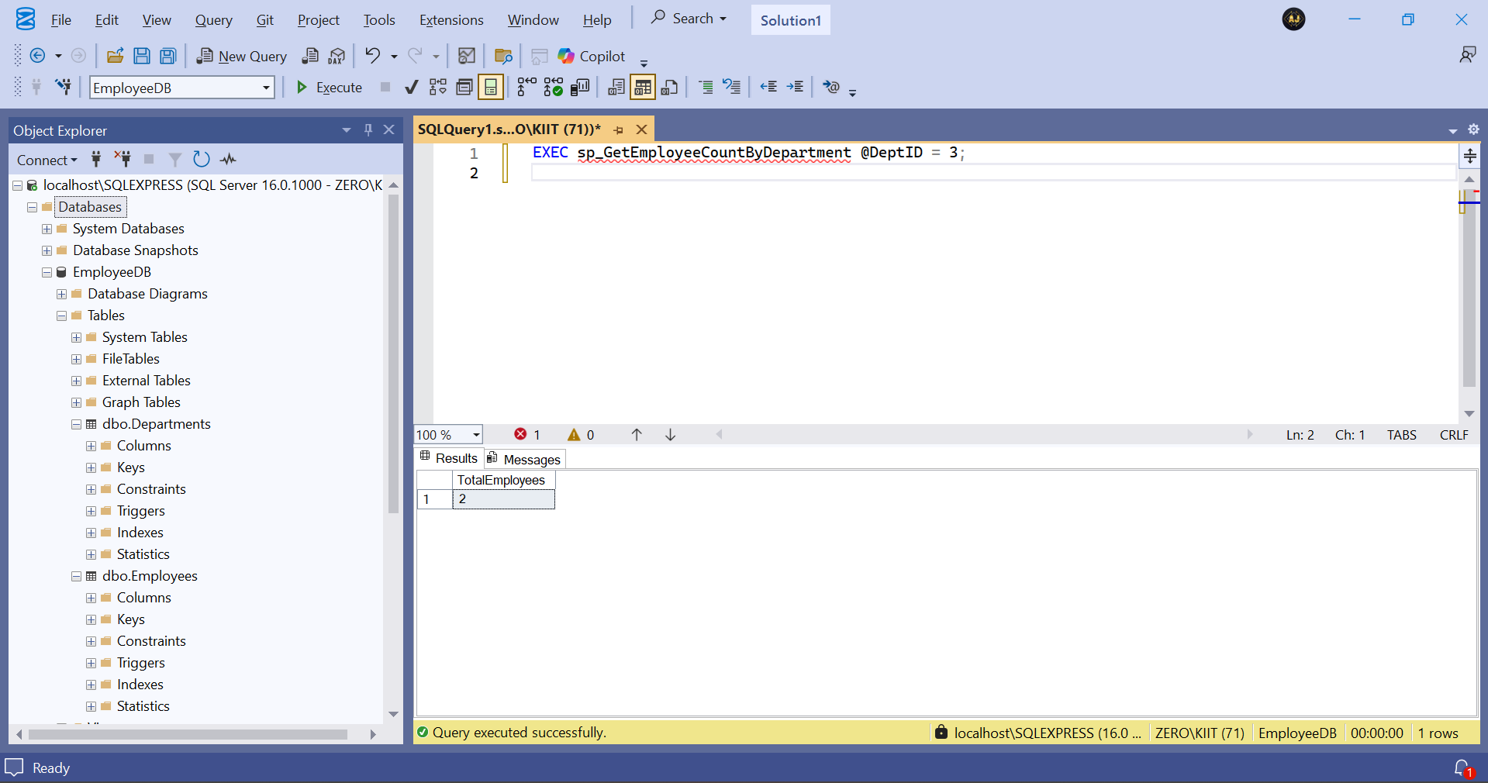

**1. NUnit-Handson**

Made a Unit Test project called CalcLibrary.Tests and added a reference to the CalcLibrary Project and made a new class called SimpleCalculatorTests.cs:

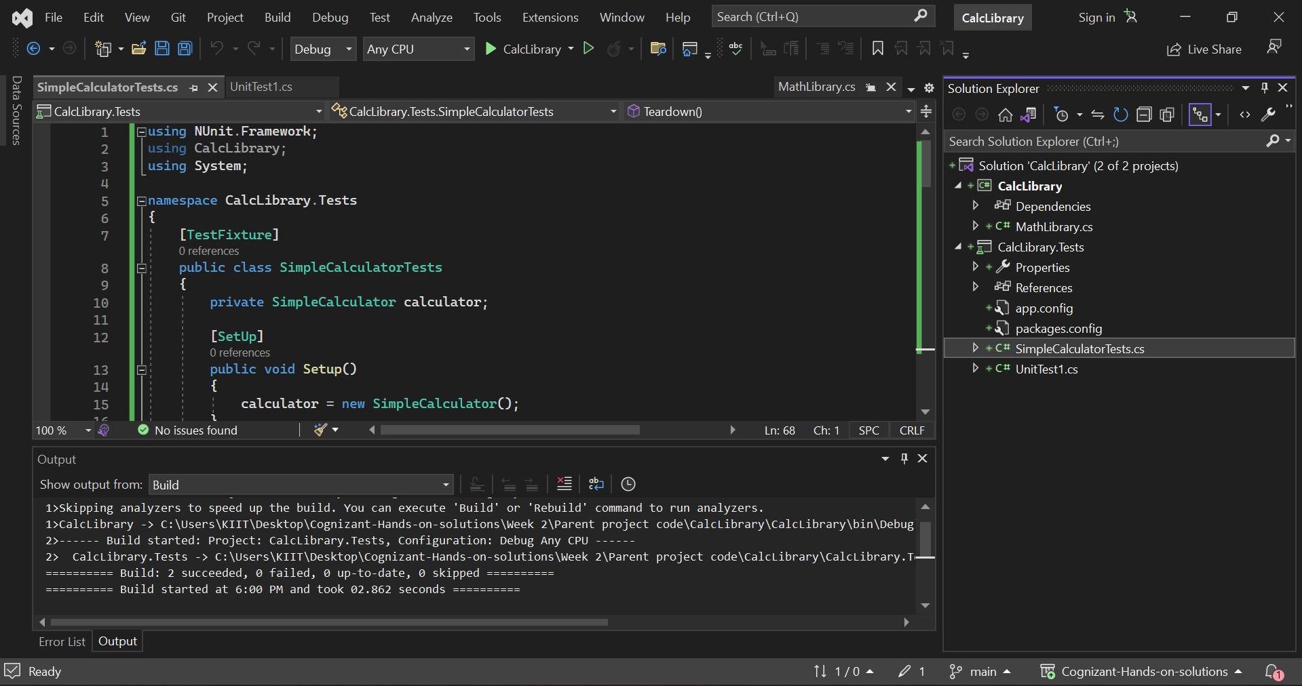

After running all the test cases:

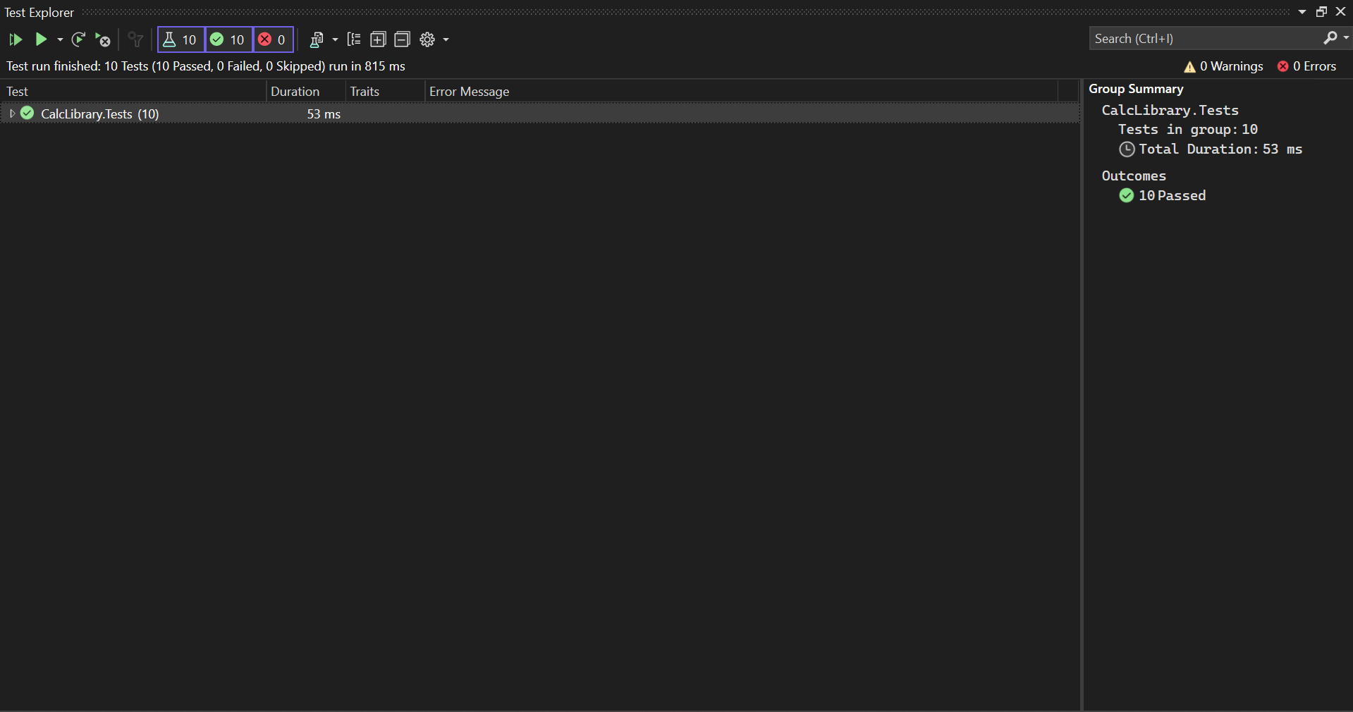

**1.Moq-Handson**

1.Write Testable Code with Moq:

Made two project folders, one for Mail Sender logic and another for testing:

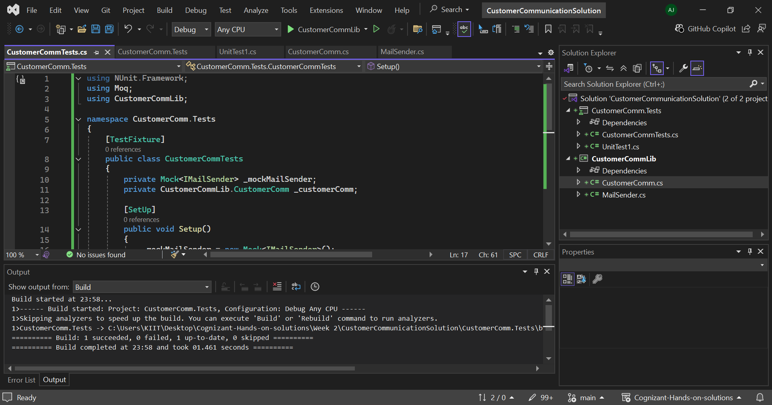

After running all the testcases:

